*M.P.C AUTONOMUS COLLEGE*

.

**PROJECT REPORT ON**

**COMPUTER SCIENCE DEPARTMENTAL WEBSITE**

***Submitted to M.P.C AUTO.COLLEGE for the partial fulfillment of***

**BACHELOR**

**IN**

**COMPUTER SCIENCE**

***Submitted By***

***NITHIS KUMAR NANDI(2318031)***



**CERTIFICATE**

This is to certify that Nitish Kumar Nandi , a student of +3 Final Year Science bearing class roll no.:BS18-066 and exam roll no:2318031 of M.P.C. (Autonomous) College , Takatpur , Baripada has carried out the project work presented in the report under direct guidance . He has submitted the project **“COMPUTER SCIENCE DEPARTMENTAL WEBSITE”** under my supervision and guidance during the session 2020-2021.

Internal Signature External Signature Coordinator Signature

**DECLARATION**

We declare that the project work entitled ***“ “***for the award of 3rd year Bachelors Degree in Computer Science to M.P.C AUTO. College represents our ideas in our own words. We have not submitted the same work for the award of any other degree. We also declare that we have adhered to all principles of academic honesty and integrity and have not misrepresented or fabricated or falsified any idea/ data/ fact/ source in submission of this project.

**ACKNOWLEDGEMENT**

On the very outset of this project, we would like to extend our sincere and heartfelt obligation towards all the personages who have helped us in the endeavor. Without their active guidance, help, cooperation, we would not have headway in this project.

We are very grateful, thankful and wish to record our indebtedness to **Asst.** **Prof. Dr. Saraoj Kumar Patra**, HOD, Department of Computer science, M.P.C AUTO. COLLEGE for her active guidance and interest in this undergoing project work.

We would also like to thank our Facaltiy Member of Department of Computer science, M.P.C AUTO COLLEGE for her continued drive for better quality in everything that allowed us to continue and carry out this project work.

Lastly, word run to express our gratitude to our parents and all the Professors, Lecturers, Technical and official staffs and friends for their co-operation, constructive criticism and valuable suggestions during the preparation of Project report.

**ABSTRACT**

Computer science commonly presents *levels* (or, less commonly, *layers*) of abstraction, wherein each level represents a different model of the same information and processes, but with varying amounts of detail. Each level uses a system of expression involving a unique set of objects and compositions that apply only to a particular domain. [[14]](https://en.wikipedia.org/wiki/Abstraction_(computer_science)#cite_note-14) Each relatively abstract, "higher" level builds on a relatively concrete, "lower" level, which tends to provide an increasingly "granular" representation. For example, gates build on electronic circuits, binary on gates, machine language on binary, programming language on machine language, applications and operating systems on programming languages. Each level is embodied, but not determined, by the level beneath it, making it a language of description that is somewhat self-contained.

**CONTENTS**

**1.INTRODUCTION**……………………………………………5-7

* Purpose of the project:
* Current and Proposed System:
* Scope of the project:
* Glossary:
* Advantages:

1.1Objectives of the Project

**2. FEASIBILITRY STUDAY ……………………………………7-8**

2.1 Technical feasibility study

2.2 Financial feasibility study

2.3 Organizational feasibility study

**3. S/W & H/W Requirement**……………………………………………8-9

**4.SYSTEM ANALYSICS……………………………………….9-10**

* Introduction
* Existing System
* Proposed System

**5.DESGINE**

5.1(Diagrams:Flowchart/ERDiagram/DFD) ………………….10-13

**4 SYSTEM DEVELOPMENT**

4.1Coding.............................................................................13-37

4.2Snapshot.…………………………………........………………37-40

**5.TESTING**………………………………………………………41

**6.SCOPE OF FUTUREAPLICATION**…………………………41-42

**7. CONCLUSION**…………………………………………………42-43

**8. BIBLIOGRAPHY………………………………………….**43-44

1. **INTRODUCTION**

**This project introduces the** “**DEPARTMENT WEBSITE OF OUR COMPUTER SCIENCE DEPARTMENT**”.

The growing significance of websites for various organizations is well known. In recognizing that we decided to develop a website for the department which compromises of all the required information about the department.

**Purpose of the project:**

The purpose of our project is to design, publish and maintain a website for our department which consists of all the information regarding the department like infrastructure, faculty, transport facilities, etc.,

**Current and Proposed System:**

**Current System:**

As the existing website is not maintained and the domain has been blocked there is a need for new one. The existing system requires a number of records and takes a huge amount of time for the process completion. When we compare the existing system with the proposed system, there are many drawbacks for the existing system. In the current system there is a chance of unauthorized access of data this may cause change in the original data and also loss of the data. These may result bad assessment in the shop performance.

**Proposal System:**

Initially the college authorities had the feeling of maintaining a comprehensive website for information exchange apart from existing one(static). We used all the possible ways to monitor the data and maintained format the data requested by the authority. Also to formulated the text to embed into World Wide Web. The data is about to change all the time some will update it all the time possible.

**Scope of the project:**

This SRS applies to all the official web applications that are developed to maintain the information online. This is extended to all the domains of the applications.

**Glossary:**

|  |  |
| --- | --- |
| TERM | DEFINATION |
| HTML | Hyper Text Markup Language |
| JSC | JavaScript Certificate |
| CSS | Cascading Style Sheets |

The above technologies are required to implement the requirements due to following advantages

**Advantages:**

• Easy to navigate

• Provides all the comprehensive information about the college

• Flash items are provided where ever necessary

• All the nostalgic images are provided in the gallery

**1.1 OBJECTIVES OF THE PROJECT**

In the “**DEPARTMENTAL WEBSITE”** project, the project can give any kind of information through reports and queries if required. This is very sophisticated to use and modify. The project is designed in such a way that it can afford any changes that occurs in future .The project can also be modified according to the needs. The user can easily handle the system

**OBJECTIVE**

* To maintain records easily
* To reduced the cheating
* The project must be simple and user friendly
* The project must be efficient
* By this software manual effort can be reduced
* To improve security.

**2. FEASIBILITY STUDY**

A feasibility study is an analysis of how successfully a project can be completed, accounting for factors that affect it such as economic, technological and operational. Project managers use feasibility studies to determine potential positive and negative outcomes of a project before investing a considerable amount of time and money into it.

During the stage of our feasibility study, we had to undergo the following steps as described under:

* + Identify the origin of data at different levels of the system.
  + Identify the expectation of end user from the finished product/system
  + Analyze the drawback(s) of the existing system.
* **Technical feasibility study**: It lays out details on how a good or service will be delivered, which includes transportation, business, location ,technology needed, materials and labour.
* **Financial feasibility study**: It is a projection of the amount of funding or startup capital needed, what sources of capital can and will be used and what kind of return can be expected on the investment.
* **Organizational feasibility study**: It is a definition of the corporate and legal structure of the business; this may include information about the founders, their professional background and the skills they possess necessary to get the company off the ground and keep it operational.

**3. SYSTEM REQUIREMENTS**

Hardware Requirements:-

* 1.6 GHz or faster processor.
* 1GB of RAM(1.5 GB if running on a virtual machine)
* 50 MB of available hard disk space.
* 5400 RPM hard disk drive.

Software Requirements:-

* Front End-Visual studio code or notepad++ or notepad.
* Back end-My Sql
* Browser-Chrome or Firefox or Internet explorer
* Operating System-
* On 64-bit windows,one of:
* Windows 7 or later

**Functional Requirments:-**

* + The system provides all the information about the department in details
  + The system gives in detail description of our department infrastructure
  + All the necessary Information is rendered with proper images and flash slides for better navigaton
  + Proper information regarding the mode of transport and available means is also included

**Non-Functional Requirments:-**

* + Runs on law performance systems and on any enviornment
  + Costs effective deployment(when buying out storage spece)
  + All the language used to develop the system are client-side scripting languages which provide dynamic system

**4.SYSTEM ANALYSIS**

**INTRODUCTION:-**

**S**ystem analysis is the purpose of gathering and interpreting facts, diagonsing problems and using the information to recommend improvemetnts on the system. System analysis is a problem solving activity that requires intensive commcunication between the system users and system developers. System analysics or study is an important phase of any system development process the system is studies to the minutes detailes and analysed the system analyst plays the role of an interrogator and dwells deep into the working of the present system. This system is viewed as a whole and the input of the system are identified. The conclusion is an understanding of how the system functions. This system is called exciting system. Now,The excisting system is subjected to close study & the problems areas are identified. The designer now function as a problem solver and tries to sort out the difficulties that the enterprise faces. The solution are called proposed system

**EXISTING SYSTEM:-**

The existing department website is static which makes it less interactive. It does not have a database connectivity. Moreover students did not have an access to the details of the department through the site.

**PROPOSED SYSTEM:-**

In order to make the site dynamic and more intractive we have tried to include a data base link to our department website . Hence the recruiters have been provided with the facility.

**5.SYSTEM DESIGN**

**INTRODUCTION:-**

System design is the solution to the creation of a new system. This phase is composed of several system. This phase focus on the detailed implementation of the feasible system. It emphasis on translating design specification to performance specification. System design has two phases of development, logical and physical design. During logical design phases the analysts describes inputs outputs etc. Here THE LOGICAL DESGINE is done through data flow diagrams and data base design . The physical design is followed by physical design or coding.

**WEB-FORM DESGINE:-**

A web forms page presents information to the user in any browser or client device and implements application logic using server side code. Webforms are based on the system. Web .UI .Page class. The class hierarchy for the page class is shown below.

* Object
* Control
* Template Control
* Page

**COMPONENTS OF WEB FORMS:-**

In web forms pages, the user interface programming is divided into two parts: the visual component(design page)and the logic(code behind page).

**HOME PAGE:-**

The home page of a website is the first page that a user perceives upon entering the website URL at the browser address area. The entire website depends on how the home page is design which forms the plat form for viewing other web forms. In sort, A home page forms the abstract of the entire web site

**LINKS AND WEBPAGES:-**

Through the homepage a number of other web page can be linked. Each link gives an elaborated detail about itself with adequate lists and photos.

**5.1 DATA FLOW DIAGRAM**

* **0-LEVEL DIAGRAM**

I.D proof

NOTICE

STUDENT

login

* **1-LEVEL DIGRAM**

I.D PROOF

STUDENT

**LOGIN**

LIST OF TOPICS

**SEMISTERDETAILS**

* **2- LEVEL DIAGRAM**

STUDENT

I.D LOGIN

SEMISTER DETAILS

**LIST OF TITLE**

DISPLAY BOOK

**ER-Diagram**

login

Has

student

Manage

Books

Course

Has

Notice

Contact

**4.1 CODING**

LOGIN PAGE

<!DOCTYPE html>

<html lang="en">

<head>

    <title>M.P.C AUTO COLLEGE COMPUTER SCIENCE</title>

    <meta charset="utf-8">

<meta name="viewport" content="width=device-width, initial-scale=1">

<meta name="Keywords" content="College, Pokhara, IT College, Lions Marga, college in pokhara, nepalIT">

 <meta name="author" content="Bishworaj Poudel">

 <link rel="stylesheet" type="text/css" href="css/style.css">

<script src="javascript/js.js="></script>

<script src="javascript/login.js"></script>

</head>

<body class="body">

<header class="mainheader">

    <img src="F:\1_20210422_120049_0000.png">

    <content id="search">

        <form>

  <input type="text" name="search" placeholder="Search anything..." onclick="window.location.href='search.html'">

</form>

    </content>

    <nav>

        <ul>

            <li><a href="index.html">Home</a></li>

            <li><a href="course.html">Course</a></li>

            <li><a href="download.html">Download</a></li>

            <li><a href="contact.html">Contact</a></li>

            <li><a href="login.html">Login</a></li>

        </ul>

    </nav>

</header>

<div class="container">

      <div class="main">

        <h3>Informatics Login</h3><hr/>

        <form id="form_id" method="post" name="myform">

          <strong>User Name :</strong></br>

          <input type="text" name="username" id="username"/></br>

           <strong>Password :</strong></br>

          <input type="password" name="password" id="password"/></br>

          <input type="button" value="Login" id="submit" onclick="validate()"/>

        </form>

        <span><b class="note">Note : </b><strong>For this demo use following username and password. <br/><b class="valid"><h4>User Name : bimalendu<br/>Password :bimalendu123</b></h4></span></strong>

      </div>

       <div class="fugo">

         <a href="F:\images (1).png"><img src="F:\images (1).png"width="50" height="50" /></a>

      </div>

    </div>

<footer class="mainFooter">

    <p>Copyright &copy <a href="https://www.facebook.com/IamBRP">Ananta::Bimalendu::Mahendra::Nitishs</a> </p>

    <center>

    <a href="https://www.facebook.com/IamBRP/">Facebook</a>

    <a href="https://www.twitter.com/IamBRP/">Twitter</a>

    <a href="https://www.youtube.com/IamBRP/">Youtube</a>

    </center>

</footer>

<script type="text/javascript">

  document.title="Login";

</script>

</body>

</html>

HOME PAGE:-

<!DOCTYPE html>

<html lang="en">

<head>

    <title>M.P.C Autonomous College</title>

    <meta charset="utf-8">

<meta name="viewport" content="width=device-width, initial-scale=1">

<meta name="Keywords" content="College, Pokhara, IT College, Lions Marga, college in pokhara, nepalIT">

 <meta name="author" content="Bishworaj Poudel">

 <link rel="stylesheet" type="text/css" href="css/style.css">

<script src="javascript/js.js="></script>

</head>

<body class="body">

<header class="mainheader">

    <img src="F:\1_20210422_120049_0000.png">

    <content id="search">

        <form>

  <input type="text" name="search" placeholder="Search anything..." onclick="window.location.href='search.html'">

</form>

    </content>

    <nav>

        <ul>

            <li><a href="index.html">Home</a></li>

            <li><a href="course.html">Course</a></li>

            <li><a href="download.html">Download</a></li>

            <li><a href="contact.html">Contact</a></li>

            <li><a href="login.html">Login</a></li>

        </ul>

    </nav>

</header>

<br>

<div class="slideshow-container">

<div class="iambrpslides fade">

  <div class="numbertext">01 / 03</div>

  <img src="http://mpcautocollege.org.in/CMS/Slider/3202018%2032732%20PM.banner2.jpg">

 </div>

<div class="iambrpslides fade">

  <div class="numbertext">02 / 03</div>

  <img src="F:\IMG20210417111633.jpg">

  </div>

<div class="iambrpslides fade">

  <div class="numbertext">03 / 03</div>

  <img src="C:\Users\Nitish kumar Nandi\Desktop\Project of ABNMR\N6dAfS0ydFgJg9LC2WWH5KDJ.jpg">

</div>

</div>

<div style="text-align:center">

  <span class="dot"></span>

  <span class="dot"></span>

  <span class="dot"></span>

</div>

<script>

var slideIndex = 0;

showSlides();

function showSlides() {

    var i;

    var slides = document.getElementsByClassName("iambrpslides");

    var dots = document.getElementsByClassName("dot");

    for (i = 0; i < slides.length; i++) {

       slides[i].style.display = "none";

    }

    slideIndex++;

    if (slideIndex> slides.length) {slideIndex = 1}

    for (i = 0; i < dots.length; i++) {

        dots[i].className = dots[i].className.replace(" active", "");

    }

    slides[slideIndex-1].style.display = "block";

    dots[slideIndex-1].className += " active";

    setTimeout(showSlides, 2500); // This is for Changing image every 2.5 seconds

}

</script>

<br>

        <script type="text/javascript">

  document.title="Home";

</script>

<script src="scripts/slider.js"></script>

<div class="mainContent">

    <div class="Content">

        <article class="topContent">

            <header>

             <h3><a href="#" title="My First Post">M.P.C AUTO.COLLEGE </a>  </h3>

            </header>

            <footer>

                <p class="post-info">Computer Science Department </p>

            </footer>

            <content>

<p>

    The Bachelor of Computer Science or

    Bachelor of Science in Computer Science

    (abbreviated BCompSc or BCS or BS CS or

    B.Sc. CS) is a type of bachelor's degree,

    usually awarded after three or four years

    of collegiate study in computer science,

    but possibly awarded in fewer years

    depending on factors such as an

    institution's course requirements andacademic calendar. In some cases it can

    be awarded in five years. In general,

    computer science degree programs

    emphasize the mathematical and

    theoretical foundations of computing.In many post-secondary institutions, an

    Honors Bachelor of Computer Science

    degree has been introduced as an upgrade

    to the regular bachelor's program and

    usually requires at least one additional

    year of study.

</p>

            </content>

        </article>

        <article class="bottomContent">

            <header>

            <h3><a href="#" title="Pathway Programme">Computer Science</a>  </h3>

            </header>

            <footer>

                <p class="post-info">Some of word from our Head of the Department</p>

            </footer>

            <content>

<p>We plan for quality higher education programmes with complete progression pathway for you – from Foundation program up to Postgraduate degree level by the universities in Australia and United Kingdom.

Our distinguished Academic and Examination Board also sets the academic and examination standards of Informatics Academy’s programmes.

We make learning exclusive for you.

We know everyone has different learning needs and lifestyles. We have learning modes ranging from traditional classroom learning, to e-learning and a combination of both to accommodate to different learning patterns.

Our holistic education programme places equal emphasis on both academic and non-academic, co-curricular activities. We strive to provide learning and support services, as well as a conducive environment for you to learn, live and develop into global thought leaders of tomorrow.

We focus in giving you the best.

</p>

            </content>

        </article>

    </div>

</div>

<aside class="top-sidebar">

    <article>

        <h3>choose the Technologys!</h3>

        <p>Embark on an exciting learning journey with Informatics</p>

    </article>

</aside>

<aside class="middle-sidebar">

    <article>

        <h3>Your won website with the android app</h3>

        <p>A Degree to stand out from the crowd…...</p>

    </article>

</aside>

<aside class="buttom-sidebar">

    <article>

        <h3>Be ahead of your peers</h3>

        <p>Fast track your education with Informatics</p>

    </article>

</aside>

<footer class="mainFooter">

    <p>Copyright &copy <a href="https://www.facebook.com/IamBRP">Ananta::Bimalendu::Mahendra::Nitish</a> </p>

    <center>

    <a href="https://www.facebook.com/IamBRP/">Facebook</a>

    <a href="https://www.twitter.com/IamBRP/">Twitter</a>

    <a href="https://www.youtube.com/IamBRP/">Youtube</a>

    </center>

</footer>

</body>

</html>

COURSE

<!DOCTYPE html>

<html lang="en">

<head>

  <title>Informatics College</title>

  <meta charset="utf-8">

<meta name="viewport" content="width=device-width, initial-scale=1">

<meta name="Keywords" content="College, Pokhara, IT College, Lions Marga, college in pokhara, nepalIT">

 <meta name="author" content="Bishworaj Poudel">

 <link rel="stylesheet" type="text/css" href="css/style.css">

<script src="javascript/js.js="></script>

</head>

<body class="body">

<header class="mainheader">

  <img src="F:\1_20210422_120049_0000.png">

  <content id="search">

    <form>

  <input type="text" name="search" placeholder="Search anything..." onclick="window.location.href='search.html'">

</form>

  </content>

  <nav>

    <ul>

      <li><a href="index.html">Home</a></li>

      <li><a href="course.html">Course</a></li>

      <li><a href="download.html">Download</a></li>

      <li><a href="contact.html">Contact</a></li>

      <li><a href="login.html">Login</a></li>

    </ul>

  </nav>

<h1>Semister 1/2</h1>

<div class="gallery">

  <a target="_blank" href="F:\images.jpeg">

    <img src="F:\images.jpeg" alt="CCT101" width="300" height="200">

  </a>

  <div class="desc">Programming in C </div>

</div>

<div class="gallery">

  <a target="_blank" href="F:\images (1).jpeg">

    <img src="F:\images (1).jpeg" alt="Html" width="300" height="200">

  </a>

  <div class="desc">Programming in c++</div>

</div>

<div class="gallery">

  <a target="_blank" href="F:\download.jpeg">

    <img src="F:\download.jpeg" alt="Database" width="300" height="200">

  </a>

  <div class="desc">Data Structure</div>

</div>

<div class="gallery">

  <a target="_blank" href="F:\-A1020-01-43-71-A102001437192-A102001437192-Lrg.jpeg">

    <img src="F:\-A1020-01-43-71-A102001437192-A102001437192-Lrg.jpeg"" alt="Database" width="300" height="200">

  </a>

  <div class="desc">Computer Organization</div>

</div>

<div id="fix"></div>

<hr>

<h1>Semister 3/4</h1>

<div class="gallery">

  <a target="_blank" href="F:\images (15).jpeg">

    <img src="F:\images (15).jpeg" alt="CCT101" width="200" height="200">

  </a>

  <div class="desc">Operating System</div>

</div>

<div class="gallery">

  <a target="_blank" href="F:\images (2).jpeg">

    <img src="F:\images (2).jpeg"" alt="Html" width="200" height="200">

  </a>

  <div class="desc">Software Engineering</div>

</div>

<div class="gallery">

  <a target="_blank" href="F:\images (16).jpeg">

    <img src="F:\images (16).jpeg"" alt="Database" width="200" height="200">

  </a>

  <div class="desc">Database Management System</div>

</div>

<div class="gallery">

  <a target="_blank" href="F:\images (3).jpeg">

    <img src="F:\images (3).jpeg"" alt="Database" width="200" height="200">

  </a>

  <div class="desc">Core Java</div>

</div>

<div class="gallery">

  <a target="_blank" href="F:\images (4).jpeg">

    <img src="F:\images (4).jpeg"" alt="Database" width="200" height="200">

  </a>

  <div class="desc">Computer Networkings</div>

</div>

<div class="gallery">

  <a target="_blank" href="F:\images (5).jpeg">

    <img src="F:\images (5).jpeg"" alt="Database" width="200" height="200">

  </a>

  <div class="desc">Computer Graphiecs</div>

</div>

<div id="fix"></div>

<hr>

<h1>Semister 5/6</h1>

<div class="gallery">

  <a target="_blank" href="F:\images (10).jpeg">

    <img src="F:\images (10).jpeg" alt="CCT101" width="300" height="200">

  </a>

  <div class="desc">Introduction to Internet Technology</div>

</div>

<div class="gallery">

  <a target="_blank" href="F:\images (11).jpeg">

    <img src="F:\images (11).jpeg" alt="Html" width="300" height="200">

  </a>

  <div class="desc">Theory Of Computation</div>

</div>

<div class="gallery">

  <a target="_blank" href="F:\images (12).jpeg">

    <img src="F:\images (12).jpeg"" alt="Database" width="300" height="200">

  </a>

  <div class="desc">Information Sequrity</div>

</div>

<div class="gallery">

  <a target="_blank" href="F:\images.png">

    <img src="F:\images.png"" alt="Database" width="300" height="200">

  </a>

  <div class="desc">Android Programming</div>

</div>

<div class="gallery">

  <a target="_blank" href="F:\images (13).jpeg">

    <img src="F:\images (13).jpeg"" alt="Database" width="300" height="200">

  </a>

  <div class="desc">Artificial Intelligence</div>

</div>

<div class="gallery">

  <a target="_blank" href="F:\download (1).jpeg">

    <img src="F:\download (1).jpeg"" alt="Database" width="300" height="200">

  </a>

  <div class="desc">Design And Analysics Of Algraithms</div>

</div>

<div class="gallery">

  <a target="_blank" href="F:\images (14).jpeg">

    <img src="F:\images (14).jpeg"" alt="Database" width="300" height="200">

  </a>

  <div class="desc">Cloud Computing</div>

</div>

<div id="fix"></div>

<hr>

<footer class="mainFooter">

  <p>Copyright &copy <a href="https://www.facebook.com/IamBRP">Ananta::Bimalendu::Mahendra::Nitishs</a> </p>

  <center>

  <a href="https://www.facebook.com/IamBRP/">Facebook</a>

  <a href="https://www.twitter.com/IamBRP/">Twitter</a>

  <a href="https://www.youtube.com/IamBRP/">Youtube</a>

  </center>

</footer>

<script type="text/javascript">

  document.title="Course";

</script>

</body>

</html>

DOWNLOAD SECTION

<!DOCTYPE html>

<html lang="en">

<head>

  <title>Informatics College</title>

  <meta charset="utf-8">

<meta name="viewport" content="width=device-width, initial-scale=1">

<meta name="Keywords" content="College, Pokhara, IT College, Lions Marga, college in pokhara, nepalIT">

 <meta name="author" content="Bishworaj Poudel">

 <link rel="stylesheet" type="text/css" href="css/style.css">

<script src="javascript/js.js="></script>

</head>

<body class="body">

<header class="mainheader">

  <img src="F:\1_20210422_120049_0000.png">

  <content id="search">

    <form>

  <input type="text" name="search" placeholder="Search anything..." onclick="window.location.href='search.html'">

</form>

  </content>

  <nav>

    <ul>

      <li><a href="index.html">Home</a></li>

      <li><a href="course.html">Course</a></li>

      <li><a href="download.html">Download</a></li>

      <li><a href="contact.html">Contact</a></li>

      <li><a href="login.html">Login</a></li>

    </ul>

  </nav>

</header>

<h1>Semister 1/2</h1>

<div class="gallery">

  <a target="_blank" href="F:\images.jpeg">

    <img src="F:\images.jpeg" alt="CCT101" width="300" height="200">

  </a>

  <div class="desc">Programming in C </div>

</div>

<div class="gallery">

  <a target="_blank" href="F:\images (1).jpeg">

    <img src="F:\images (1).jpeg" alt="Html" width="300" height="200">

  </a>

  <div class="desc">Programming in c++</div>

</div>

<div class="gallery">

  <a target="_blank" href="F:\download.jpeg">

    <img src="F:\download.jpeg" alt="Database" width="300" height="200">

  </a>

  <div class="desc">Data Structure</div>

</div>

<div class="gallery">

  <a target="_blank" href="F:\-A1020-01-43-71-A102001437192-A102001437192-Lrg.jpeg">

    <img src="F:\-A1020-01-43-71-A102001437192-A102001437192-Lrg.jpeg"" alt="Database" width="300" height="200">

  </a>

  <div class="desc">Computer Organization</div>

</div>

<div id="fix"></div>

<hr>

<h1>Semister 3/4</h1>

<div class="gallery">

  <a target="_blank" href="F:\images (15).jpeg">

    <img src="F:\images (15).jpeg" alt="CCT101" width="200" height="200">

  </a>

  <div class="desc">Operating System</div>

</div>

<div class="gallery">

  <a target="_blank" href="F:\images (2).jpeg">

    <img src="F:\images (2).jpeg"" alt="Html" width="200" height="200">

  </a>

  <div class="desc">Software Engineering</div>

</div>

<div class="gallery">

  <a target="_blank" href="F:\images (16).jpeg">

    <img src="F:\images (16).jpeg"" alt="Database" width="200" height="200">

  </a>

  <div class="desc">Database Management System</div>

</div>

<div class="gallery">

  <a target="_blank" href="F:\images (3).jpeg">

    <img src="F:\images (3).jpeg"" alt="Database" width="200" height="200">

  </a>

  <div class="desc">Core Java</div>

</div>

<div class="gallery">

  <a target="_blank" href="F:\images (4).jpeg">

    <img src="F:\images (4).jpeg"" alt="Database" width="200" height="200">

  </a>

  <div class="desc">Computer Networkings</div>

</div>

<div class="gallery">

  <a target="_blank" href="F:\images (5).jpeg">

    <img src="F:\images (5).jpeg"" alt="Database" width="200" height="200">

  </a>

  <div class="desc">Computer Graphiecs</div>

</div>

<div id="fix"></div>

<hr>

<h1>Semister 5/6</h1>

<div class="gallery">

  <a target="_blank" href="F:\images (10).jpeg">

    <img src="F:\images (10).jpeg" alt="CCT101" width="300" height="200">

  </a>

  <div class="desc">Introduction to Internet Technology</div>

</div>

<div class="gallery">

  <a target="_blank" href="F:\images (11).jpeg">

    <img src="F:\images (11).jpeg" alt="Html" width="300" height="200">

  </a>

  <div class="desc">Theory Of Computation</div>

</div>

<div class="gallery">

  <a target="_blank" href="F:\images (12).jpeg">

    <img src="F:\images (12).jpeg"" alt="Database" width="300" height="200">

  </a>

  <div class="desc">Information Sequrity</div>

</div>

<div class="gallery">

  <a target="_blank" href="F:\images.png">

    <img src="F:\images.png"" alt="Database" width="300" height="200">

  </a>

  <div class="desc">Android Programming</div>

</div>

<div class="gallery">

  <a target="_blank" href="F:\images (13).jpeg">

    <img src="F:\images (13).jpeg"" alt="Database" width="300" height="200">

  </a>

  <div class="desc">Artificial Intelligence</div>

</div>

<div class="gallery">

  <a target="_blank" href="F:\download (1).jpeg">

    <img src="F:\download (1).jpeg"" alt="Database" width="300" height="200">

  </a>

  <div class="desc">Design And Analysics Of Algraithms</div>

</div>

<div class="gallery">

  <a target="_blank" href="F:\images (14).jpeg">

    <img src="F:\images (14).jpeg"" alt="Database" width="300" height="200">

  </a>

  <div class="desc">Cloud Computing</div>

</div>

<div id="fix"></div>

<hr>

<footer class="mainFooter">

  <p>Copyright &copy <a href="https://www.facebook.com/IamBRP">Ananta::Bimalendu::Mahendra::Nitish</a> </p>

  <center>

  <a href="https://www.facebook.com/IamBRP/">Facebook</a>

  <a href="https://www.twitter.com/IamBRP/">Twitter</a>

  <a href="https://www.youtube.com/IamBRP/">Youtube</a>

  </center>

</footer>

<script type="text/javascript">

  document.title="Download";

</script>

</body>

</html>

CONTACT SECTION:-

<!DOCTYPE html>

<html lang="en">

<head>

  <title>Informatics College</title>

  <meta charset="utf-8">

<meta name="viewport" content="width=device-width, initial-scale=1">

<meta name="Keywords" content="College, Pokhara, IT College, Lions Marga, college in pokhara, nepalIT">

 <meta name="author" content="Bishworaj Poudel">

 <link rel="stylesheet" type="text/css" href="css/style.css">

<script src="javascript/js.js"></script>

<script src="javascript/validatename.js"></script>

</head>

<body class="body">

<header class="mainheader">

  <img src="F:\1_20210422_120049_0000.png">

  <content id="search">

    <form>

  <input type="text" name="search" placeholder="Search anything..." onclick="window.location.href='search.html'">

</form>

  </content>

<nav>

    <ul>

      <li><a href="index.html">Home</a></li>

      <li><a href="course.html">Course</a></li>

      <li><a href="download.html">Download</a></li>

      <li><a href="contact.html">Contact</a></li>

      <li><a href="login.html">Login</a></li>

    </ul>

  </nav>

</header>

<img src="F:\images (17).jpeg" width="300" height="350" frameborder="0" style="border:0" allowfullscreen></iframe>

<h3>Contact</h3>

<h4>M.P.C AUTO. COLLEGE Department OF Computer Science<br>

Takatpur,Baripada</h4>

Mayurbhanj, Odisha, India

<pre>

Phone : Fax-06792 252612

+91 22-27782183<br>

Email :  mpcautocollege@gmail.com info@mpcautocollege.org.in<br>

Facebook : http://facebook.com/informaticscollegepkr<br>

</pre>

<!DOCTYPE html>

<html>

<body>

<br>

<br>

<strong>If you are student please enter your student number:</strong>

<center>

<input id="numb">

<button type="button" onclick="myFunction()">Submit</button>

<p id="demo"></p>

</center>

<hr>

<footer class="mainFooter">

  <p>Copyright &copy <a href="https://www.facebook.com/IamBRP">Ananta::Bimalendu::Mahendra::Nitish</a> </p>

  <center>

  <a href="https://www.facebook.com/IamBRP/">Facebook</a>

  <a href="https://www.twitter.com/IamBRP/">Twitter</a>

  <a href="https://www.youtube.com/IamBRP/">Youtube</a>

  </center>

</footer>

<script>

function myFunction() {

    var x, text;

    // Get the value of the input field with id="numb"

    x = document.getElementById("numb").value;

    // If x is Not a Number or less than one or greater than 10

    if (isNaN(x) || x < 1 || x > 3000000) {

        text = "";

    } else {

        text = "welcome to the department ";

    }

    document.getElementById("demo").innerHTML = text;

}

</script>

</body>

</html>

<script type="text/javascript">

  document.title="Contact";

</script>

</body>

</html>

CSS DESGINE:-

h2{

 background-color: #70750f;

 padding: 30px 35px;

 margin: -10px -50px;

 text-align:center;

 border-radius: 10px 10px 0 0;

}

hr{

 margin: 10px -50px;

 border: 0;

 border-top: 1px solid rgb(63, 35, 35);

 margin-bottom: 40px;

}

div.container{

 width: 900px;

 height: 610px;

 margin:35px auto;

 font-family: 'Raleway', sans-serif;

}

div.main{

 width: 300px;

 padding: 10px 50px 25px;

 border: 2px solid rgb(77, 34, 34);

 border-radius: 10px;

 font-family: raleway;

 float:left;

 margin-top:50px;

}

input[type=text],input[type=password]{

 width: 100%;

 height: 40px;

 padding: 5px;

 margin-bottom: 25px;

 margin-top: 5px;

 border: 2px solid rgb(88, 47, 47);

 color: #661313;

 font-size: 16px;

 border-radius: 5px;

}

label{

 color: #530d0d;

 text-shadow: 0 1px 0 rgb(85, 27, 27);

 font-size: 14px;

 font-weight: bold;

}

center{

 font-size:32px;

}

.note{

 color:red;

}

.valid{

 color:green;

}

.back{

 text-decoration: none;

 border: 1px solid rgb(0, 143, 255);

 background-color: rgb(0, 214, 255);

 padding: 3px 20px;

 border-radius: 2px;

 color: black;

}

input[type=button]{

 font-size: 16px;

 background: linear-gradient(#ffbc00 5%, #ffdd7f 100%);

 border: 1px solid #e5a900;

 color: #4E4D4B;

 font-weight: bold;

 cursor: pointer;

 width: 100%;

 border-radius: 5px;

 padding: 10px 0;

 outline:none;

}

input[type=button]:hover{

 background: linear-gradient(#ffdd7f 5%, #ffbc00 100%);

}

.fugo{

 float:right;

}

body{

  background-image: url("F:\uhd.jpg");

    color: white;

  font-size: 87.5%;

  /*Font Size is 14 */

  font-family: Arial, "Comic Sans Ms";

  line-height: 1.5;

  text-align: left;

}

div.gallery {

    margin: 5px;

    border: 1px solid rgb(3, 5, 136);

    float:left;

    width: 140px;

}

div.gallery:hover {

    border: 1px solid #777;

}

div.gallery img {

    width: 100%;

    height: auto;

}

#fix{

  clear: both;

}

div.desc {

    padding: 15px;

    text-align: center;

}

iframe{

  float: right;

}

a{

  text-decoration: none;

  color: white;

}

a:link, a:visited{

color: #CF5C3F;

}

a:hover, a:active{

background-color: #CF5C3F;

color:#fff;

}

.body{

margin: 0 auto;

width: 70%;

clear: both;

}

.mainheader img{

  width: 30%;

  height: auto;

  margin: 2% 0;

}

.mainheader nav{

background-color: #666;

height: 40px;

line-height: 40px;

border-radius: 5px;

-moz-border-radius: 5px;

-webkit-border-radius: 5px;

}

.mainheader nav ul {

list-style-type: none;

margin: 0 auto;

}

.mainheader nav ul li {

list-style-type: none;

margin: 0 auto;

float: left;

display: inline-block;

}

.mainheader nav a:link, .mainheader nav a:visited{

color: #fff;

padding: 10px 25px;

height: 20px;

}

.mainheader nav a:hover, .mainheader nav a:active,

.mainheader nav .active a:link, .mainHeader nav .active a:visited

{

 background-color: #cf5c3F;

 text-shadow: none;

}

.mainheader nav ul li a{

  border-radius: 5px;

-moz-border-radius: 5px;

-webkit-border-radius: 5px;

}

.mainContent{

  line-height: 25px;

  border-radius: 5px;

-moz-border-radius: 5px;

-webkit-border-radius: 5px;

}

.Content{

  width: 70%;

  float: left;

  border-radius: 5px;

  -moz-border-radius: 5px;

-webkit-border-radius: 5px;

}

.topContent{

  background-color: rgb(0,0,60);

line-height: 25px;

border-radius: 5px;

-moz-border-radius: 5px;

-webkit-border-radius: 5px;

padding: 3% 5%;

margin-top: 2%;

}

.bottomContent{

background-color: rgb(0,0,60);

line-height: 25px;

border-radius: 5px;

-moz-border-radius: 5px;

-webkit-border-radius: 5px;

padding: 3% 5%;

margin-top: 2%;

}

.top-sidebar{

width: 21%;

float: left;

background-color: rgb(128, 2, 65);

border-radius: 5px;

-moz-border-radius: 5px;

-webkit-border-radius: 5px;

padding: 2% 3%;

margin: 2% 0 2% 3%;

}

.middle-sidebar{

width: 21%;

float: left;

background-color: rgb(75, 3, 133);

border-radius: 5px;

-moz-border-radius: 5px;

-webkit-border-radius: 5px;

margin-left: 3%;

padding: 2% 3%;

margin-bottom: 2%;

}

.buttom-sidebar{

width: 21%;

float: left;

background-color: rgb(1, 29, 150);

border-radius: 5px;

-moz-border-radius: 5px;

-webkit-border-radius: 5px;

margin-left: 3%;

padding: 2% 3%;

margin-bottom: 2%;

}

.mainFooter{

width: 100%;

float: left;

border-radius: 5px;

-moz-border-radius: 5px;

-webkit-border-radius: 5px;

background-color: rgb(2, 87, 99);

margin-top: 6%;

margin-bottom: 2%;

}

.mainFooter p{

  width: 92%

  margin: 10px auto;

  color: #000s;

  padding: 2px;

  height: 40px;

  text-align: center;

}

.mainFooter a{

  color: rgba(129, 1, 91, 0.966);

}

#search{

  float: right;

}

#search input[type=text] {

    width: 100%;

    box-sizing: border-box;

    border: 2px solid rgb(182, 46, 46);

    border-radius: 4px;

    font-size: 16px;

    background-color: white;

    background-image: url('../images/searchicon.png');

    background-position: 10px 10px;

    background-repeat: no-repeat;

    padding: 10px 40px 12px 40px;

}

.post-info{

  font-style: italic;

  color: #999;

  font-size: 90%;

}

* {box-sizing:border-box}

body {font-family: Verdana,sans-serif;}

.iambrpslides {display:none}

/* Slideshow container */

.slideshow-container {

  max-width: 1000px;

  position: relative;

  margin: auto;

}

/* Number text (1/3 etc) */

.numbertext {

  color: #f2f2f2;

  font-size: 12px;

  padding: 8px 12px;

  position: absolute;

  top: 0;

}

/* The dots/bullets/indicators */

.dot {

  height: 13px;

  width: 13px;

  margin: 0 2px;

  background-color: #bbb;

  border-radius: 50%;

  display: inline-block;

  transition: background-color 0.6s ease;

}

.active {

  background-color: #717171;

}

/* Fading animation */

.fade {

  -webkit-animation-name: fade;

  -webkit-animation-duration: 1.5s;

  animation-name: fade;

  animation-duration: 1.5s;

}

@-webkit-keyframes fade {

  from {opacity: .4}

  to {opacity: 1}

}

@keyframes fade {

  from {opacity: .4}

  to {opacity: 1}

}

/* On smaller screens, decrease text size */

@media only screen and (max-width: 300px) {

  .text {font-size: 11px}

}

img{

  width: 100%;

  height: 350px;

}

**4.2 SNAPSHOT**

LOGIN PAGE

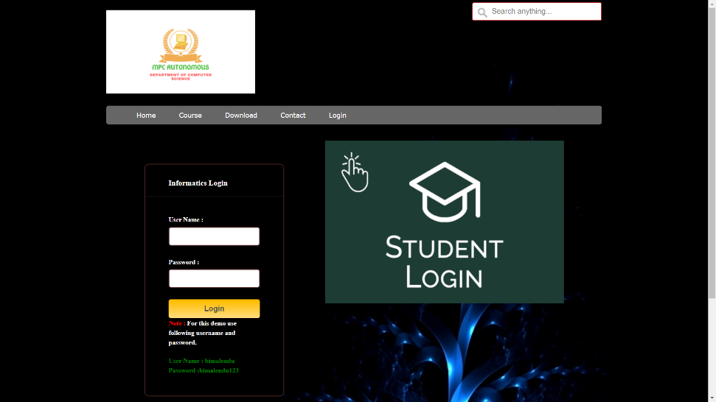

MAIN MENU

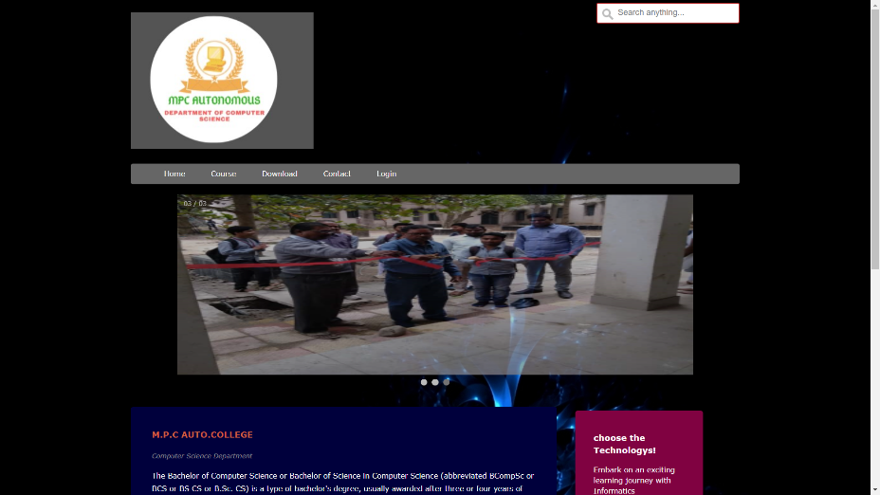

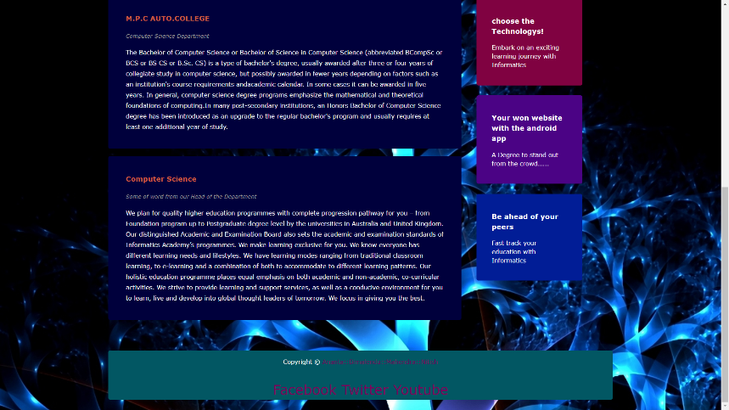

**COURSE SECTION:-**

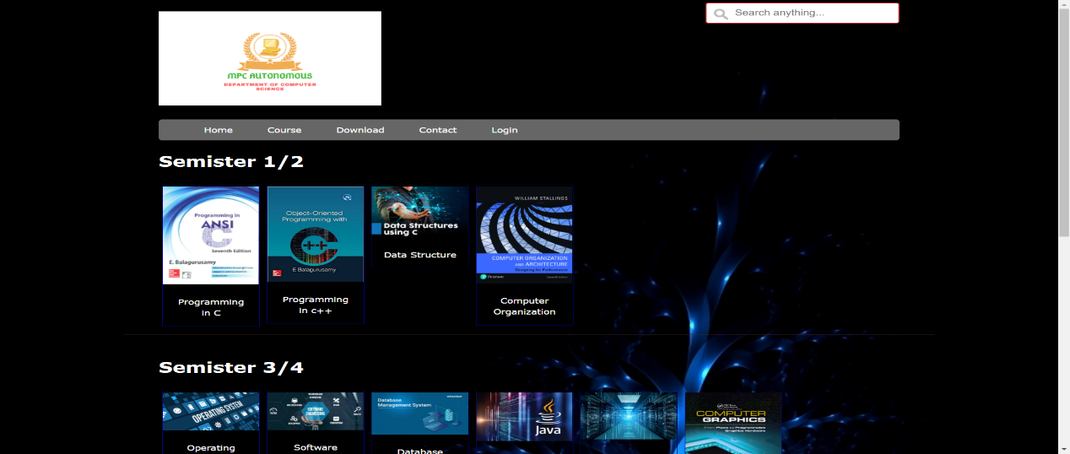

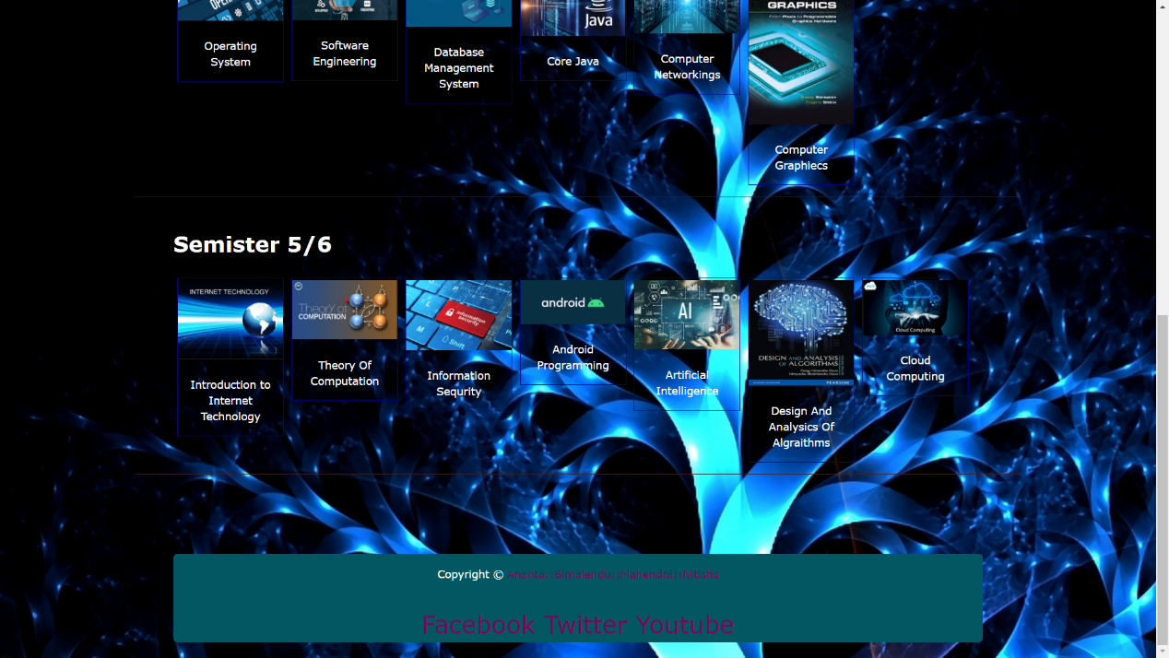

DOWNLOAD SECTION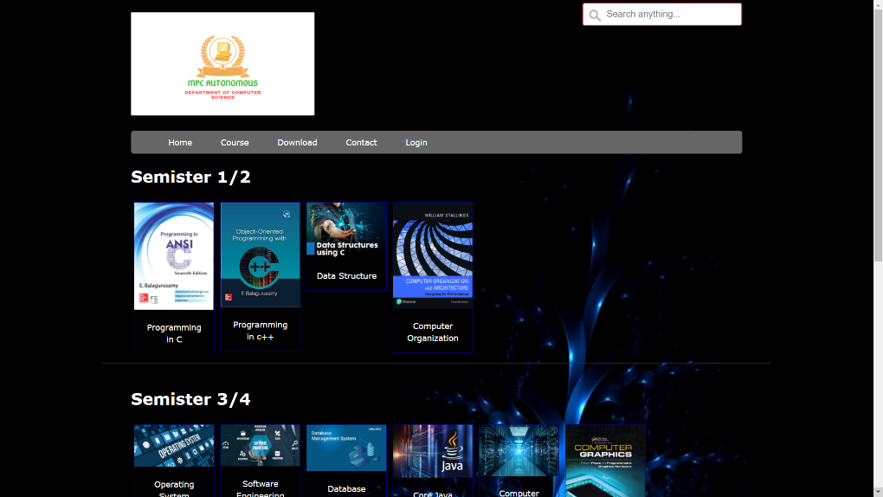

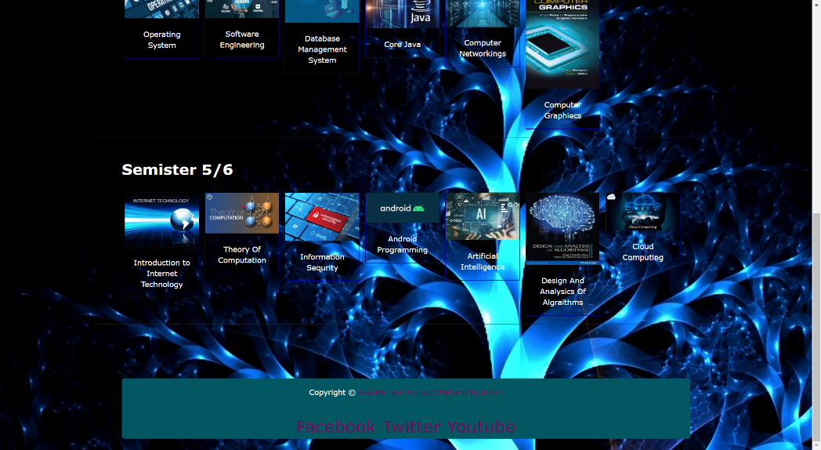

CONTACT SECTION:-

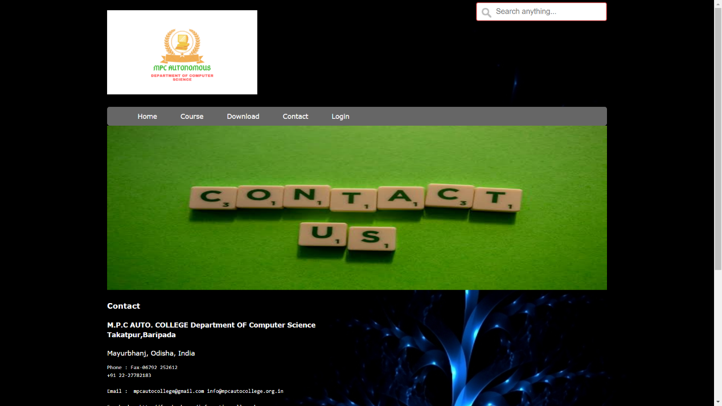

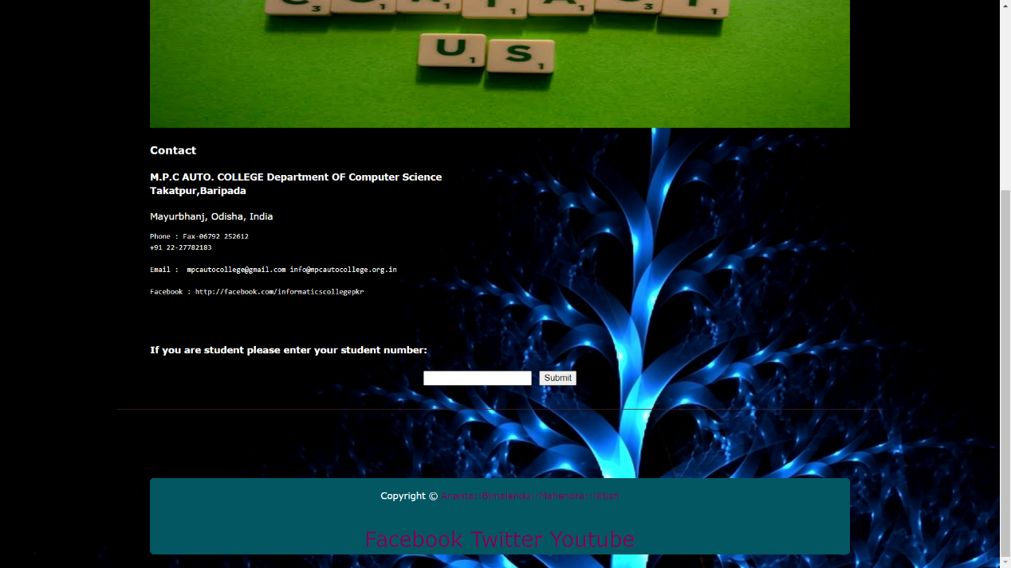

**5. TESTING**

* Testing is the process of evaluating a system or its components with the intent to find whether it satisfies the specified requirements or not.
* Testing is executing a system in order to identify any gaps, error, or missing requirements in contrary to the actual requirements.
* A test strategy is an outline that describes the testing approach of the offline development cycle. It is created to inform project managers, testers, and developers about some key issues of the testing process.
* This includes the testing new functions, total time and resources required for the project, and the testing environment.

**6. SCOPE OF FUTURE APPLICATION**

Here we tried to develop the project by analyzing the current system and we consider the situation of manual system.

It is possible to make this system more dynamic by analyzing every side of the manual system.

The following prominent features will be added in the future

* We will try to make this system more easier and useful for the user
* We will make this site more Information for the user.
* It will be very user friendly.

**7. CONCLUSION**

The project titled “**DEPARTMENT WEBSITE OF OUR COMPUTER SCIENCE DEPARTMENT**” developed under Windows environment using Visual studio code is an attempt to implement the proposed system.

**DEPARTMENT WEBSITE OF OUR COMPUTER SCIENCE DEPARTMENT ::** The main objective of the project is to computerize the existing system where all the process was carried out manually. I had put my sincere effort to implement this project.

Full attempt is made to make the software bug free but as we know “to error is human”.

8. BIBLIOGRAPHY

This project would not have been complete and got its final shape without the help and support which i have received from various sources. A lot of information has been collected from various books and internet resources.

* Jennifer Niederst Robbins, Learning Web Design(A beginners guide to HTML, CSS, JAVASCRIPT) 5TH Edition.
* Ben Frain, Responsive Web Design with HTML5 and CSS3.
* David Sawyer McFarland, JAVASCRIPT & JQuery, 3RD Edition.

Without the assistance of these book and valuable sites, this project would have been curtailed. So I am very much obliged and grateful to these sources.